PIZZA SALES SQL

Total Revenue

SELECT SUM(total_price)AS Total_Revenew

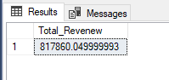FROM pizza_sales;

Average Oder Value

SELECT SUM(total_price) / COUNT(DISTINCT order_id)AS Average_Oder_Value FROM pizza_sales;

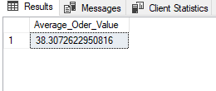

Total Pizza Sold

SELECT SUM(quantity) AS Total_Pizza_Sold FROM pizza_sales;

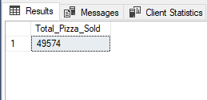

Total Orders

SELECT COUNT(DISTINCT order_id)AS Total_Orders FROM pizza_sales; 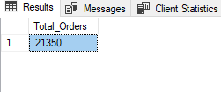

Avg Num of Pizza sold

SELECT CAST(CAST (SUM(quantity) AS DECIMAL(10,2))/

CAST(COUNT(DISTINCT order_id)AS DECIMAL(10,2)) AS DECIMAL(10,2))AS Avg_Num_of_Pizza_sold FROM pizza_sales;

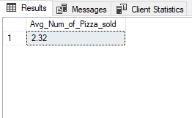

Daily Trend for Total Orders

SELECT DATENAME(DW , order_date) AS order_day,

COUNT(DISTINCT order_id) AS total_order

FROM pizza_sales

GROUP BY DATENAME(DW , order_date);

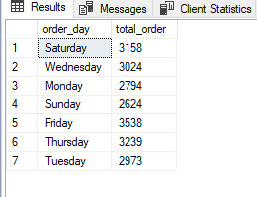

Monthly Trend for Total Orders

SELECT DATENAME(MONTH, order_date) AS Month_Name,

COUNT(DISTINCT order_id) AS total_order

FROM pizza_sales

GROUP BY DATENAME(MONTH, order_date) ORDER BY total_order DESC; 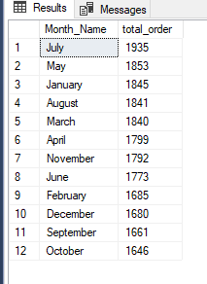

PCT

SELECT pizza_category ,

SUM(total_price) AS total_sales,

SUM(total_price) * 100 /

(SELECT SUM(total_price)FROM pizza_sales) AS PCT

FROM pizza_sales

GROUP BY pizza_category;

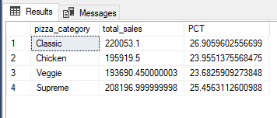

PCT on Pizza Size

SELECT pizza_size ,SUM(total_price) AS total_sales,

SUM(total_price) * 100 /(SELECT SUM(total_price)FROM pizza_sales) AS PCT

FROM pizza_sales GROUP BY pizza_size;

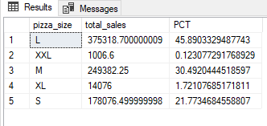

TOP 5 BEST PIZZA MADE REVRNUE

SELECT TOP 5 pizza_name,SUM(total_price) AS Pizza_sold FROM pizza_sales

GROUP BY pizza_name

ORDER BY Pizza_sold DESC;

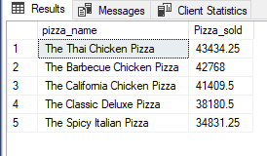

TOP 5 WORST PIZZA MADE NO REVRNUE

SELECT TOP 5 pizza_name,SUM(total_price) AS Pizza_sold FROM pizza_sales

GROUP BY pizza_name

ORDER BY Pizza_sold ASC;

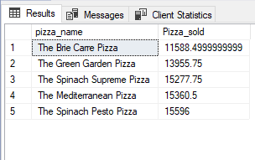

BEST SELLER PIZZA

SELECT TOP 5 pizza_name,SUM(quantity) AS Pizza_Quantity FROM pizza_sales

GROUP BY pizza_name

ORDER BY Pizza_Quantity DESC;

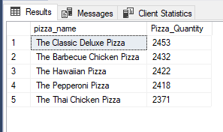

WORST SELLER PIZZA

SELECT TOP 5 pizza_name,SUM(quantity) AS Pizza_Quantity FROM pizza_sales

GROUP BY pizza_name

ORDER BY Pizza_Quantity ASC;

